LTA Assistant (Level 1) – Deployment without Disclosure and Barring Service (DBS) check
Dear Candidate,
If you do not have an accepted DBS check completed through the LTA, please complete your name below and provide this letter to the tennis venue where you will be completing your experience hours for the Level 1 course.
You should then return this letter to the Course Provider (company running the LTA Assistant course) before your course starts.

Candidate’s name:…………………………………………………………………………………………

Dear Tennis Venue,
The above candidate is enrolled on the LTA Assistant (Level 1) tennis coaching qualification course and will be completing their 4 hours of coaching experience at your tennis venue.
Please note that this candidate has not completed a DBS check through the LTA. Whilst this does not prohibit them from completing their coaching experience at your venue, you should ensure they are supervised accordingly by the relevant staff/coaches.
By signing this letter, you confirm that you are responsible for supervising the candidate and managing any risk associated with using them.
If you have any questions or concerns, you should discuss these in the first instance with the candidate and with the Course Provider.
Thank you for supporting new coaching assistants in British Tennis.

Signature of Club Committee Member, Manager/Chairman or Head Coach (the Supervisor):
Name of tennis venue represented by the Supervisor:
Printed name of the Supervisor:
Position of the Supervisor:
Contact number for the Supervisor:
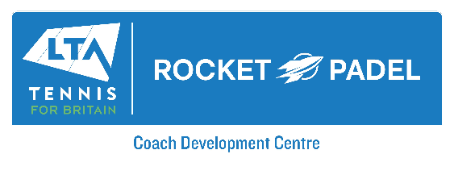

Contact: kathy.howard@rocketpadel.com

